SEC Form 3
FORM 3 | UNITED STATES SECURITIES AND EXCHANGE COMMISSION  Washington, D.C. 20549  INITIAL STATEMENT OF BENEFICIAL OWNERSHIP OF SECURITIES  Filed pursuant to Section 16(a) of the Securities Exchange Act of 1934  or Section 30(h) of the Investment Company Act of 1940
  OMB APPROVAL
  OMB Number: | 3235-0104
  Estimated average burden
  hours per response: | 0.5
1. Name and Address of Reporting Person*  (Street) | 2. Date of Event Requiring Statement (Month/Day/Year)  05/06/2026 | 3. Issuer Name and Ticker or Trading Symbol  PEPSICO INC [ PEP ]
  Gibbs David W
  (Last) | (First) | (Middle)
  PEPSICO, INC.
  700 ANDERSON HILL ROAD
  PURCHASE | NY | 10577
  (City) | (State) | (Zip)
 |  | 4. Relationship of Reporting Person(s) to Issuer  (Check all applicable) | 5. If Amendment, Date of Original Filed (Month/Day/Year)
   | Director |  | 10% Owner
   | Officer (give title below) |  | Other (specify below)
6. Individual or Joint/Group Filing (Check Applicable Line)
Form filed by One Reporting Person
Form filed by More than One Reporting Person

Table I - Non-Derivative Securities Beneficially Owned
1. Title of Security (Instr. 4) | 2. Amount of Securities Beneficially Owned (Instr. 4) | 3. Ownership Form: Direct (D) or Indirect (I) (Instr. 5) | 4. Nature of Indirect Beneficial Ownership (Instr. 5)
PepsiCo, Inc. Common Stock | 0 | D
Table II - Derivative Securities Beneficially Owned
(e.g., puts, calls, warrants, options, convertible securities)
1. Title of Derivative Security (Instr. 4) | 2. Date Exercisable and Expiration Date (Month/Day/Year) |  | 3. Title and Amount of Securities Underlying Derivative Security (Instr. 4) |  | 4. Conversion or Exercise Price of Derivative Security | 5. Ownership Form: Direct (D) or Indirect (I) (Instr. 5) | 6. Nature of Indirect Beneficial Ownership (Instr. 5)
1. Title of Derivative Security (Instr. 4) | Date Exercisable | Expiration Date | Title | Amount or Number of Shares | 4. Conversion or Exercise Price of Derivative Security | 5. Ownership Form: Direct (D) or Indirect (I) (Instr. 5) | 6. Nature of Indirect Beneficial Ownership (Instr. 5)
Explanation of Responses:
Remarks:
Exhibit List Exhibit 24 - Power of Attorney
 | /s/ Cynthia A. Nastanski, Attorney-in-Fact | 05/08/2026
 | ** Signature of Reporting Person | Date
Reminder: Report on a separate line for each class of securities beneficially owned directly or indirectly.
* If the form is filed by more than one reporting person, see Instruction 5 (b)(v).
** Intentional misstatements or omissions of facts constitute Federal Criminal Violations See 18 U.S.C. 1001 and 15 U.S.C. 78ff(a).
Note: File three copies of this Form, one of which must be manually signed. If space is insufficient, see Instruction 6 for procedure.
Persons who respond to the collection of information contained in this form are not required to respond unless the form displays a currently valid OMB Number.
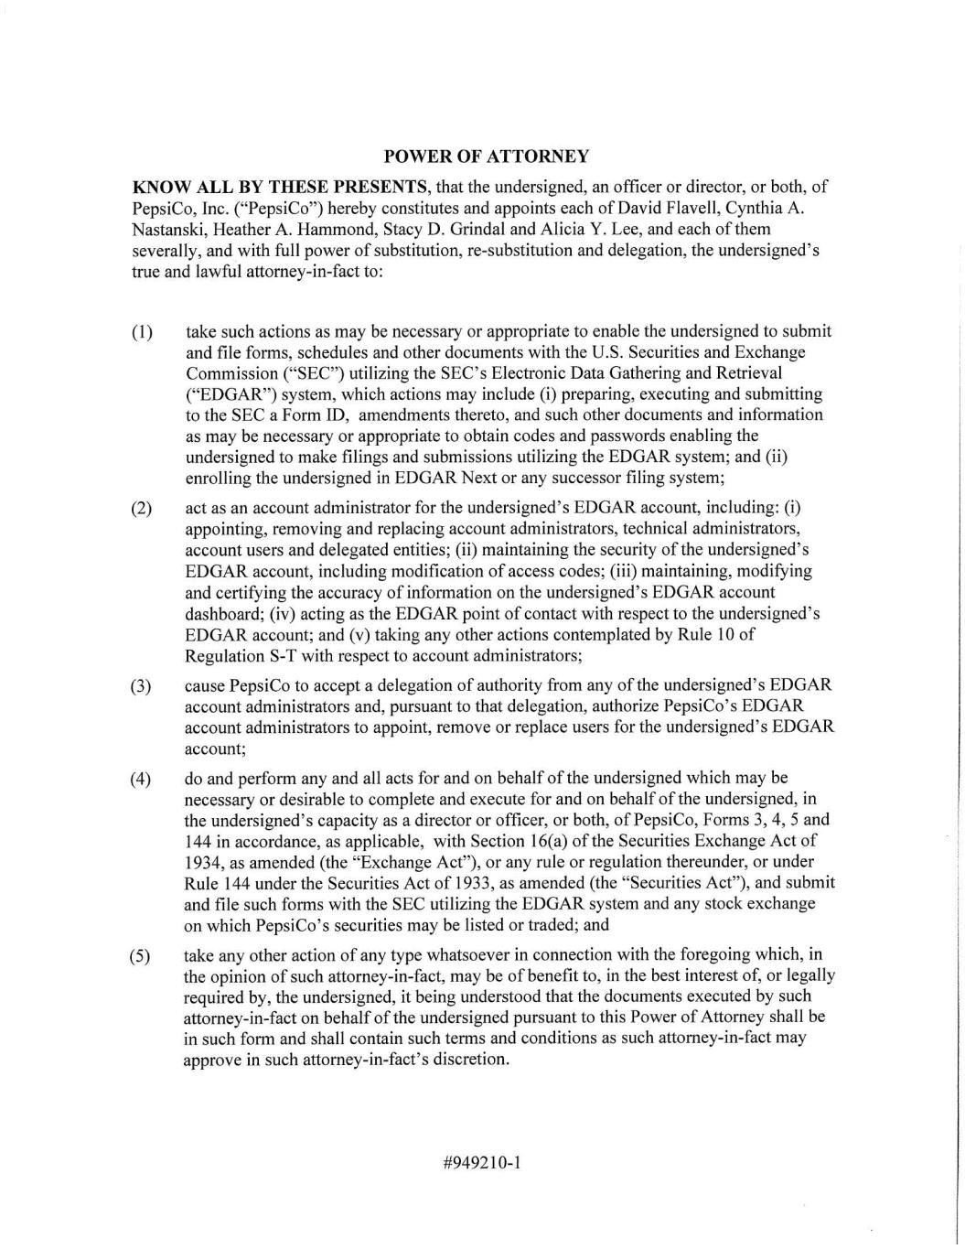
POWER OF ATTORNEY KNOW ALL BY THESE PRESENTS, that the undersigned, an officer or director, or both, of PepsiCo, Inc. ("PepsiCo") hereby constitutes and appoints each of David Flavell, Cynthia A. Nastanski, Heather A. Hammond, Stacy D. Grindal and Alicia Y. Lee, and each of them severally, and with full power of substitution, re-substitution and delegation, the undersigned's true and lawful attorney-in-fact to: (1) take such actions as may be necessary or appropriate to enable the undersigned to submit and file forms, schedules and other documents with the U.S. Securities and Exchange Commission ("SEC") utilizing the SEC's Electronic Data Gathering and Retrieval ("EDGAR") system, which actions may include (i) preparing, executing and submitting to the SEC a Form ID, amendments thereto, and such other documents and information as may be necessary or appropriate to obtain codes and passwords enabling the undersigned to make filings and submissions utilizing the EDGAR system; and (ii) enrolling the undersigned in EDGAR Next or any successor filing system; (2) act as an account administrator for the undersigned's EDGAR account, including: (i) appointing, removing and replacing account administrators, technical administrators, account users and delegated entities; (ii) maintaining the security of the undersigned's EDGAR account, including modification of access codes; (iii) maintaining, modifying and certifying the accuracy of information on the undersigned's EDGAR account dashboard; (iv) acting as the EDGAR point of contact with respect to the undersigned's EDGAR account; and (v) taking any other actions contemplated by Rule 10 of Regulation S-T with respect to account administrators; cause PepsiCo to accept a delegation of authority from any of the undersigned's EDGAR account administrators and, pursuant to that delegation, authorize PepsiCo's EDGAR account administrators to appoint, remove or replace users for the undersigned's EDGAR account; (4) do and perform any and all acts for and on behalf of the undersigned which may be necessary or desirable to complete and execute for and on behalf of the undersigned, in the undersigned's capacity as a director or officer, or both, of PepsiCo, Forms 3, 4, 5 and 144 in accordance, as applicable, with Section 16(a) of the Securities Exchange Act of 1934, as amended (the "Exchange Act"), or any rule or regulation thereunder, or under Rule 144 under the Securities Act of 1933, as amended (the "Securities Act"), and submit and file such forms with the SEC utilizing the EDGAR system and any stock exchange on which PepsiCo's securities may be listed or traded; and take any other action of any type whatsoever in connection with the foregoing which, in the opinion of such attorney-in-fact, may be of benefit to, in the best interest of, or legally required by, the undersigned, it being understood that the documents executed by such attorney-in-fact on behalf of the undersigned pursuant to this Power of Attorney shall be in such form and shall contain such terms and conditions as such attorney-in-fact may approve in such attorney-in-fact's discretion. (3) (5) #949210-1

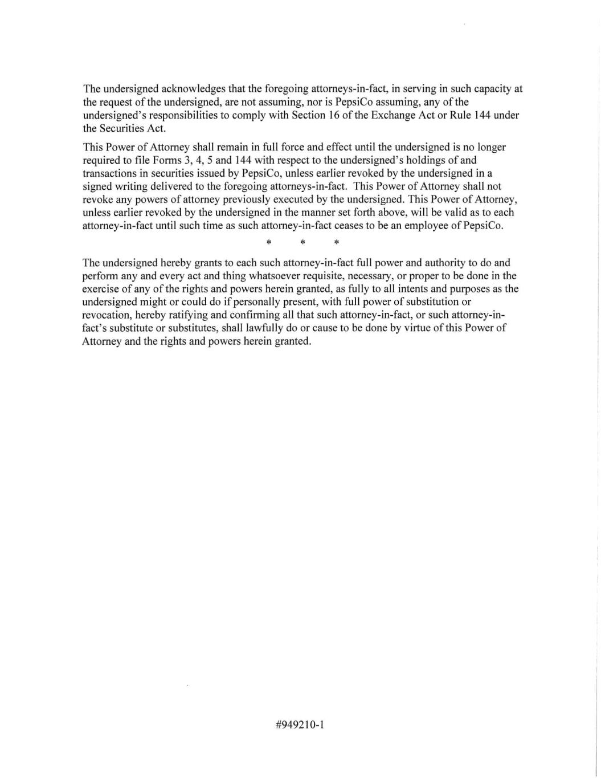
The undersigned acknowledges that the foregoing attorneys-in-fact, in serving in such capacity at the request of the undersigned, are not assuming, nor is PepsiCo assuming, any of the undersigned's responsibilities to comply with Section 16 of the Exchange Act or Rule 144 under the Securities Act. This Power of Attorney shall remain in full force and effect until the undersigned is no longer required to file Forms 3, 4, 5 and 144 with respect to the undersigned's holdings of and transactions in securities issued by PepsiCo, unless earlier revoked by the undersigned in a signed writing delivered to the foregoing attorneys-in-fact. This Power of Attorney shall not revoke any powers of attorney previously executed by the undersigned. This Power of Attorney, unless earlier revoked by the undersigned in the manner set forth above, will be valid as to each attorney-in-fact until such time as such attorney-in-fact ceases to be an employee of PepsiCo. * * * The undersigned hereby grants to each such attorney-in-fact full power and authority to do and perform any and every act and thing whatsoever requisite, necessary, or proper to be done in the exercise of any of the rights and powers herein granted, as fully to all intents and purposes as the undersigned might or could do if personally present, with full power of substitution or revocation, hereby ratifying and confirming all that such attorney-in-fact, or such attorney-in- fact's substitute or substitutes, shall lawfully do or cause to be done by virtue of this Power of Attorney and the rights and powers herein granted. #949210-1

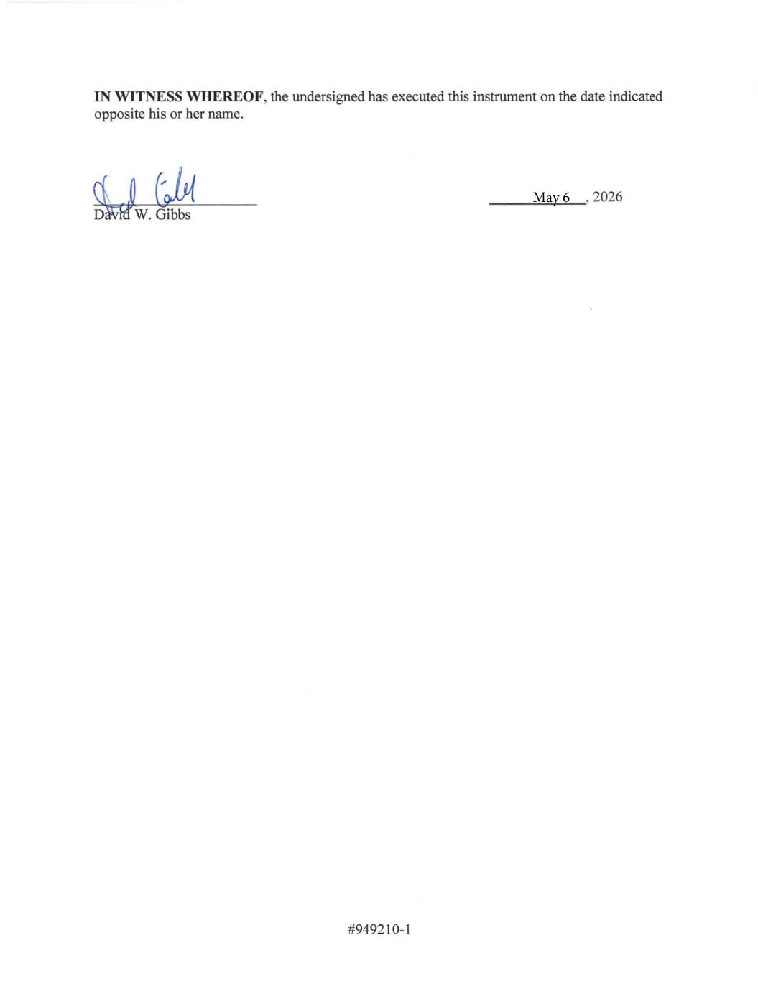
IN WITNESS WHEREOF, the undersigned has executed this instrument on the date indicated opposite his or her name. DMIKW. Gibbs , 2026 #949210-1 May 6

